CHEMISTRY
Year 12 Unit 3
MARKING KEY

1 | C |  | 14 | D
2 | A |  | 15 | B
3 | D |  | 16 | B
4 | D |  | 17 | C
5 | A |  | 18 | A
6 | B |  | 19 | C
7 | C |  | 20 | A
8 | A |  | 21 | A
9 | B |  | 22 | D
10 | D |  | 23 | B
11 | C |  | 24 | B
12 | C |  | 25 | D
13 | A

Question 26 (6 marks)
(a) Why is the electrolyte essential? (2 marks)

Description | Marks
ions in the electrolyte conduct charge in the solution | 1
as pure water does not conduct electricity | 1
Total | 2
(b) State the names of all the ions that migrate to the
(i) cathode.
(ii) anode. (2 marks)
Description | Marks
cathode. sodium ions and hydrogen ions | 1
anode. sulfate ions and oxygen ions | 1
Total | 2

(c) Write half-equations for the reactions occurring at the
(i) cathode.
(ii) anode. (2 marks)

Description | Marks
cathode. 2 H⁺(aq) + 2 e– → H₂(g) | 1
anode. H₂O(ℓ) → O₂(g) + 4 H⁺(aq) + 4 e– | 1
Total | 2

Question 27 (15 marks)
(a) What assumption must be made about the reaction vessel? Explain your answer. (2 marks)

Description | Marks
closed vessel | 1
so no gas can escape (allowing an equilibrium to occur) | 1
Total | 1

(b) Complete the table indicating what will happen if the following changes are made. Assume sufficient time is allowed to reach a new equilibrium each time. (6 marks)

Description | Marks
Change made to equilibrium Effect on ppO₂(g) Effect on value of K  Temperature is reduced to 50.0 °C. increase decrease  Volume of reaction vessel is decreased decrease none  A catalyst is added none none | 1-2  1-2  1-2
Total | 6

(c) Use collision theory and your knowledge of reaction rates to explain how the addition of O₂(g) at 100.0 °C affects the equilibrium system and the partial pressures of each gas from just before the O₂(g) is added until just after equilibrium is re-established. (7 marks)

Description | Marks
just before: (system is at equilibrium and) rate of Forward and Reverse reactions are equal to each other | 1
adding O₂(g): increases ppO₂(g) and therefore increases the frequency of collisions between O₂(g) and CO(g) | 1
rate of forward reaction increases while rate of reverse initially remains constant | 1
increased frequency of collisions between O₂(g) and CO(g) increases the ppCO₂(g) | 1
this allows increased frequency of collisions between CO₂(g) molecules increasing the rate of Reverse reaction (while rate of Forward reaction falls) | 1
eventually the rate of Forward reaction and Reverse reaction will become equal and a new equilibrium will exist | 1
just after new equilibrium: slightly higher ppO₂(g) and ppCO₂(g) and slightly lower ppCO(g) | 1
Total | 7

(a) Label the conjugate acid–base pairs on the equation. (2 marks)

Description | Marks
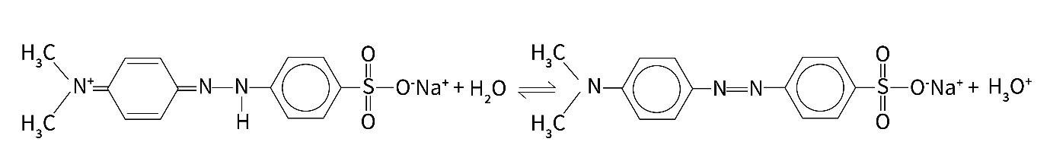  acid base conjugate base conjugate acid | 1-2
Total | 2

(b) Using a suitable example of an acid and base, explain why this indicator is used in titrations between weak bases and strong acids. (5 marks)
Description | Marks
strong acid = hydrochloric or sulfuric | 1
weak base = ammonia | 1
the equivalence point in these titrations produces an acidic ion e.g. produces NH₄⁺(aq) ions | 1
acidic ion hydrolyses/produces H₃O⁺(aq)  OR gives equation  NH₄⁺(aq) + H₂O(ℓ) ⇌ NH₃(aq) + H₃O⁺(aq) | 1
requiring an indicator (methyl orange) which changes colour in acidic conditions | 1
Total | 5

(a) Calculate the pH of the mixture when 19.00 mL of acid has been added from the burette.
(6 marks)
Description | Marks
n(H⁺) = 0.01900 × 0.1000 = 0.001900 mol and  n(OH–) = 0.02000 × 0.1000 = 0.00200 mol | 1
n(OH–) in xs = 0.00200 - 0.001900 = 1.00 × 10^{–4} mol | 1
new total volume = 0.0200 + 0.019 = 0.039 L | 1
[OH–] = 1.00 × 10^{–4} ÷ 0.03900 = 2.5640 × 10^{–3} mol L^{–1} | 1
[H⁺] = 1 × 10^{–14} ÷ 2.5640 × 10^{–3} = 3.900 × 10^{–12} mol L^{–1} | 1
pH = 11.4089 | 1
Total | 6

(b) Use your answer to part (a) (use pH = 11 if you did not obtain an answer) and the following information to construct a pH curve for the titration from initially 20.00 mL of sodium hydroxide until 30.00 mL of hydrochloric acid has been added. (6 marks)

pH of the mixture when 21.00 mL of acid has been added ≈ 2.6
pH of the mixture when 30.00 mL of acid has been added ≈ 1.7

Description | Marks
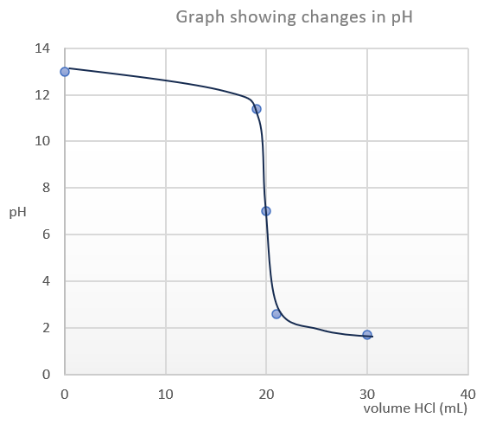
correct scale and labels for axes | 1-2
points correct at:  pH 13 at 0 mL HCℓ (initial 0.1000 mol L⁻¹ NaOH(aq))  *pH 11.4 (OR uses 11) at 19 mL HCℓ  pH 7 at 20 mL HCℓ  pH 2.6 at 21 mL HCℓ  pH 1.7 at 30 mL HCℓ | 1-3
points joined in a curve | 1
Total | 6

Question 30 (8 marks)
(a) Complete the diagram below and briefly describe what is meant by “electrorefining copper.”

Description | Marks
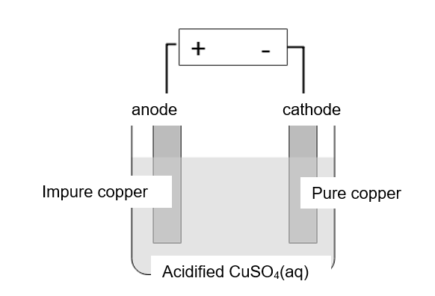
anode and cathode | 1
electrodes | 1
electrolyte | 1
small voltage applied to impure copper anode which oxidises (dissolving/removing impurities) and pure copper reduces/deposits at cathode. | 1
Total | 4

(b) Complete the diagram below and briefly describe what is meant by “electroplating silver.”

Description | Marks
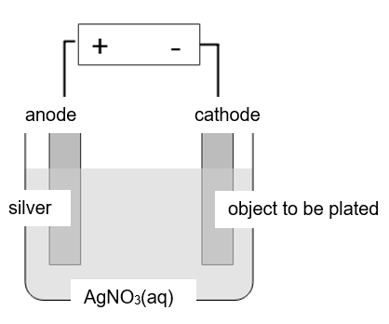
anode and cathode | 1
electrodes | 1
electrolyte | 1
a thin coating of silver ‘plated’ onto an object (made from another type of metal) by applying a voltage to a silver anode which oxidises while silver ions deposit on the cathode (object to be plated) | 1
Total | 4

Question 31 (11 marks)
(a) Is phosphoric acid strong or weak? Explain your answer. (3 marks)

Description | Marks
weak | 1
low Ka value | 1
Ka measures the extent of acid ionisation/extent of proton transfer from acid to water | 1
Total | 3

(b) Write equation 2 as an Arrhenius acid equation and use it to differentiate between the Arrhenius and Brønsted-Lowry theories of acids. (4 marks)

Description | Marks
H₂PO₄–(aq) ⇌ HPO₄^{2–}(aq) + H⁺(aq) | 1
Arrhenius theory states acids produce H⁺(aq) in water as shown above | 1
Brønsted-Lowry theory allows for proton transfer between species | 1
in this case proton transfer from H₂PO₄–(aq) to H₂O(ℓ) | 1
Total | 4

(c) Write a balanced ionic equation for the reaction between phosphoric acid and excess sodium hydroxide solution. Explain whether this reaction will go to completion. (4 marks)

Description | Marks
H₃PO₄(aq) + 3 OH–(aq) → PO₄^{3–}(aq) + 3 H₂O(ℓ) | 1-2
yes reaction goes to completion | 1
the reaction of OH–(aq) with H₃O⁺(aq) (produced as phosphoric acid ionises) drives the equilibrium of the weak acid ionisation further to the right until reaction complete | 1
Total | 4

Question 32 (6 marks)
(a) Explain how the oxidation number of lead in Pb₃O₄(s) appears not to be a whole number.
(3 marks)
Description | Marks
ON of Oxygen = -2 giving a total -ve charge of -8 which is not divisible by 3 | 1
so this lead oxide must consist of two formula units of PbO (ON = +2) | 1
and one of PbO₂ (ON = +4) (giving a total charge of +8) | 1
Total | 3

(b) Explain how paint can protect against corrosion of iron. (3 marks)

Description | Marks
paint forms a protective layer over the iron | 1
this prevents access to oxygen (and water) | 1
both of which are required for corrosion | 1
Total | 3

Question 33 (9 marks)
(a) cathodic protection (3 marks)

Description | Marks
corrosion of steel pipeline reduced/inhibited by making it cathodic | 1
steel pipeline is put at a -ve potential by connecting to low voltage DC source to an anode | 1
anode is a steel block which gradually corrodes in preference to the pipeline | 1
Total | 3

(b) sacrificial anode (3 marks)

Description | Marks
steel pipeline is connecting electrically to a more reactive metal | 1
this metal (a sacrificial anode)corrodes in preference protecting the steel | 1
metals such as magnesium, zinc and aluminium are suitable | 1
Total | 3

(c) galvanising (3 marks)

Description | Marks
steel pipeline is coated in zinc | 1
the zinc oxidises and forms a stable basic zinc carbonate layer | 1
this prevents further corrosion of the (more reactive) zinc and protects the steel underneath | 1
Total | 3

Question 34 (14 marks)
(a) Calculate the volume of commercial hydrochloric acid (10.2 mol L^{–1}) required to reduce the pH of the pool from 7.80 to 7.20. (5 marks)
Description | Marks
at pH 7.2 [H⁺(aq)] = 6.31 × 10^{–8} mol L^{–1} | 1
at pH 7.8 [H⁺(aq)] = 1.59 × 10^{–8} mol L^{–1} | 1
Δ[H⁺(aq)] = 6.31 × 10^{–8} – 1.59 × 10^{–8} = 4.72 10^{–8} mol L^{–1} | 1
n(H⁺(aq)) = 4.72 × 10^{–8} × 35,000 = 1.652 × 10^{–4} | 1
v(H⁺(aq)) = 1.652 × 10^{–4} ÷ 10.2 = 1.619 × 10^{–4} L = 0.16 mL | 1
Total | 5

(b) Use the buffer equation to describe, with reference to Le Châtelier’s principle, how the calculated volume in part (a) is incorrect. (6 marks)
Description | Marks
the answer in (a) assumes the water is not buffered | 1
a buffer solution resists pH changes to the pool water | 1
(so in the presence of a buffer) a much larger volume (than 0.16 mL) of acid is required to reduce the pH from 7.8 to 7.2 | 1
refers to Le Châtelier’s principle and equation  When a small amount of acid is added to the buffered solution the [H₃O⁺(aq)] increases | 1
the reaction will shift left to counteract the added H₃O⁺(aq) | 1
as the HCO₃–(aq) in the buffer reacts with the added H₃O⁺(aq) maintaining pH | 1
Total | 6

(c) Calculate the mass of pool buffer required to raise its concentration to from 75 to 105 ppm assuming the pool volume is unchanged at 35,000 L. (3 marks)
Description | Marks
calculation may be done in several ways:
Given: 50,000 L requires 1 kg to raise by 10 ppm | 1
so 3 kg required for 30 ppm (105-75) increase in 50,000 L pool | 1
for a 35,000 L pool ÷ 50,000 × 3 kg = 2.1 kg required | 1
Total | 3

Question 35 (13 marks)
(a) Complete the table below identifying some aspects of this experiment. (7 marks)
Description | Marks
Independent variable mass of metal carbonate  Dependent variable volume of acid used  Controlled variables (state three) [HCℓ(aq)]  Same burette  Same temperature  potential random error not transferring all the solid solid not all dissolved incorrect rinsing of conical flask  potential systematic error balance not calibrated burette read consistently incorrectly burette rinsed incorrectly | 1  1  1-3  1  1
Total | 7

(b) Complete the table below listing three pieces of equipment the students might use in this experiment. For each one state its use in this experiment. The first one has been completed for you. (6 marks)
Description | Marks
Equipment Use in this experiment  electronic balance measure mass of metal carbonate  any three suitable answers  watch glass (or similar) put solid on to measure mass  conical flask to hold solid and water for titration  measuring cylinder (or similar) to measure approx. 20 mL of water  burette titrate measurable volume of hydrochloric acid | 1-6
Total | 6

Question 36 (12 marks)
(a) List three steps describing how the reactivity of the halogens can be tested using these chemicals. (3 marks)

Description | Marks
add each halogen in turn | 1
to each metal halide | 1
and observe if a reaction occurs by a colour change | 1
Total | 3

(b) Write a balanced ionic equation for one reaction of the chemicals listed above that will be spontaneous. (2 marks)
Description | Marks
many possible answers  e.g. Cℓ₂(aq) + 2 Br–(aq) → 2 Cℓ–(aq) + Br₂(aq) | 1-2
Total | 2

(c) Write ionic half equations and a full redox equation for this reaction in which both species produce chlorine gas. (5 marks)

Description | Marks
reduction  2 CℓO₃–(aq) + 12 H⁺(aq) + 10 e– → Cℓ₂(aq) + 6H₂O(ℓ) | 1-2
oxidation  2 Cℓ–(aq) → Cℓ₂(aq) + 2 e– (× 5) | 1
full redox  2 CℓO₃–(aq) + 12 H⁺(aq) + 10 Cℓ–(aq) → 6 Cℓ₂(aq) + 6H₂O(ℓ) | 1-2
allow 1 mark if reduction and oxidation equations are in correct place and equations have some merit
 | 5

(d) Write observations for any reaction that might occur. (2 marks)

Description | Marks
2 colourless liquids mixed | 1
some brown colour appears | 1
Total | 2

Question 37 (23 marks)

(a) Starting with 1.00 tonne of beach sand, calculate the minimum mass of anhydrous titanium dioxide (TiO₂(s)) (99.8% pure) that can be produced. State your answer to the appropriate number of significant figures. (4 marks)

Description | Marks
- tonne beach sand contains a minimum of 45.0% of 3.00% pure titanium dioxide  mass = 1 × 0.45 × 0.03 =  = 0.0135 tonnes | 1
= 13,500 g | 1
m(anhydrous TiO₂) at 99.8% purity = 13500 × 100 ÷ 99.8 = 13527 g | 1
= 1.35 × 10⁴ g (13.5 kg or 0.0135 tonnes) to 3 sf | 1
Total | 4

(b) What assumption must be made about the production of titanium dioxide from beach sand for the value you obtained in part (a) to be correct. (1 mark)

Description | Marks
100% efficient | 1
Total | 1

(c) Calculate the minimum volume of concentrated sulfuric acid (65.0% by weight) required to completely react with 100.0 kg of beach sand containing 3.00% ilmenite (FeTiO₃(s)).
(7 marks)
Description | Marks
m(FeTiO₃(s)) pure = 100.0 × 10³ g × 3/100 = 3,000 g | 1
n(FeTiO₃(s)) = 3,000 ÷ 151.72 = 19.773 mol | 1
n(H₂SO₄(aq)) = 2 × 19.773 = 39.546 mol | 1
m(H₂SO₄(aq)) pure = 39.546 × 98.076 = 3,878.6 g | 1
using 65.0% sulfuric acid where 1.00 g occupies 0.654 mL
at 65% m(H₂SO₄(aq)) solution = 3878.6 × 100/65 = 5967.0 g of solution | 1
v(H₂SO₄(aq)) solution = 5967.0 g × 0.6545 mL = 3905.4 mL = 3.90 L | 1
allow 1 mark for correct calculation of molar masses | 1
Total | 7

(d) Explain why it is important to remove any FeSO₄(s) from the mixture. (2 marks)
Description | Marks
FeSO₄(s) is green (and easily oxidises to brown Fe³⁺) | 1
and will contaminate/discolour the pure white TiO₂ | 1
Total | 2

(e) Calculate the concentration of the sulfuric acid in mol L⁻¹. (4 marks)

Description | Marks
n(NaOH) = 0.01474 × 0.5780 = 8.520 × 10⁻³ mol | 1
n(H₂SO₄) in 10.00 mL = ½ × 8.520 × 10⁻³ = 4.260 × 10⁻³ mol | 1
[H₂SO₄]dil = 4.260 × 10⁻³ ÷ 0.01000 = 0.4260 mol L⁻¹ | 1
[H₂SO₄]conc = 250/10 × 0.4260 = 10.6 mol L⁻¹ | 1
Total | 4

(f) If 1.55 g of this concentrated acid solution occupies a volume of 1.00 mL confirm by calculation it is a 65.0% by weight sulfuric acid solution. (Use 10.0 mol L⁻¹ if you did not obtain an answer in part (e)) (5 marks)

Description | Marks
[H₂SO₄] = 10.65 mol L⁻¹ | 1
c(H₂SO₄) g L⁻¹ = 10.65 × 98.076 = 1044.47 g L⁻¹ | 1
= 1.04447 g in 1.00 mL of solution | 1
= 1.04447 g ÷ 1.55 g × 100 = 67.4% | 1
So acid is slightly more concentrated than stated | 1
Total | 5

Description | Marks
using [H₂SO₄] = 10.0 mol L⁻¹ | 1
c(H₂SO₄) g L⁻¹ = 10.0 × 98.076 = 980.76 g L⁻¹ | 1
= 0.98076 g in 1.00 mL of solution | 1
= 0.98076 g ÷ 1.55 g × 100 = 64.5% | 1
So acid is slightly less/same concentrated than stated | 1
Total | 5

Question 38 (24 marks)
(a) Write a balanced equation for the reversible reaction of carbon monoxide with iron(III) oxide. (3 marks)
Description | Marks
Fe₂O₃(s) + 3 CO(g) ⇌ 2 Fe(ℓ) + 3 CO₂(g) | 1-2
1 mark ⇌ | 1
Total | 3

(b) Explain the impact of increased atmospheric carbon dioxide gas on coral reefs. Consider the effects of both ocean temperature and acidity. (8 marks)
Description | Marks
temperature:  CO₂(g) is a greenhouse gas | 1
its increased presence leads to an increased surface temperature of the Earth | 1
this in turn increases ocean temperatures | 1
coral are very susceptible to temperature changes and can die/bleach | 1
Total | 4

Description | Marks
acidity:  increased [CO₂(g)] in atmosphere leads to increased [CO₂(aq)] in ocean | 1
this increases the [H₂CO₃(aq)] and lowers pH (increases acidity) | 1
this shifts the carbonate equilibrium in the ocean and decreases [CO₃^{2–}(aq)] | 1
this decreases the ability of coral to form a skeleton/shell from Ca²⁺(aq) and CO₃^{2–}(aq) | 1
Total | 4

(c) Write a balanced equation for this reaction. (2 marks)
Description | Marks
Fe₂O₃(s) + 3 H₂(g) → Fe(s) + 3 H₂O(g) | 1-2
Total | 2

(d) How this can be considered ‘green chemistry’? (1 mark)

Description | Marks
no pollutants or greenhouse gases produced (only water is produced) | 1
Total | 1

(e) Complete the fuel cell below. (4 marks)
Label
- inputs and products
- electrodes

Description | Marks
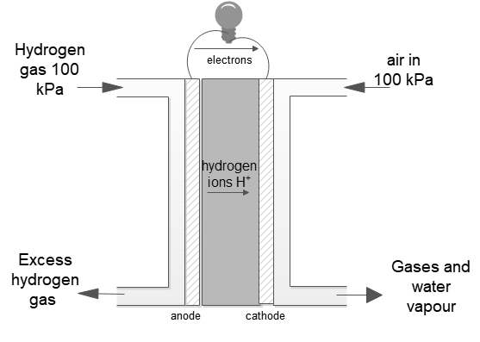 | 1
anode and cathode | 1
hydrogen in and xs hydrogen out | 1
air in | 1
water vapour out | 1
Total | 4

(f) How is a fuel cell different from a

(i) primary cell? Give an example of a primary cell. (3 marks)

Description | Marks
fuel cell has a continuous supply of redox chemicals  whereas a primary cell contains a fixed amount of redox chemicals | 1
and is not rechargeable | 1
e.g. Leclanche or dry cell | 1
Total | 3

(ii) secondary cell? Give an example of a secondary cell. (3 marks)

Description | Marks
(fuel cell has a continuous supply of redox chemicals)  a secondary cell can be recharged to resupply redox chemicals | 1
by applying a voltage to reverse the redox reaction | 1
e.g. lead acid accumulator/car battery | 1
Total | 3

